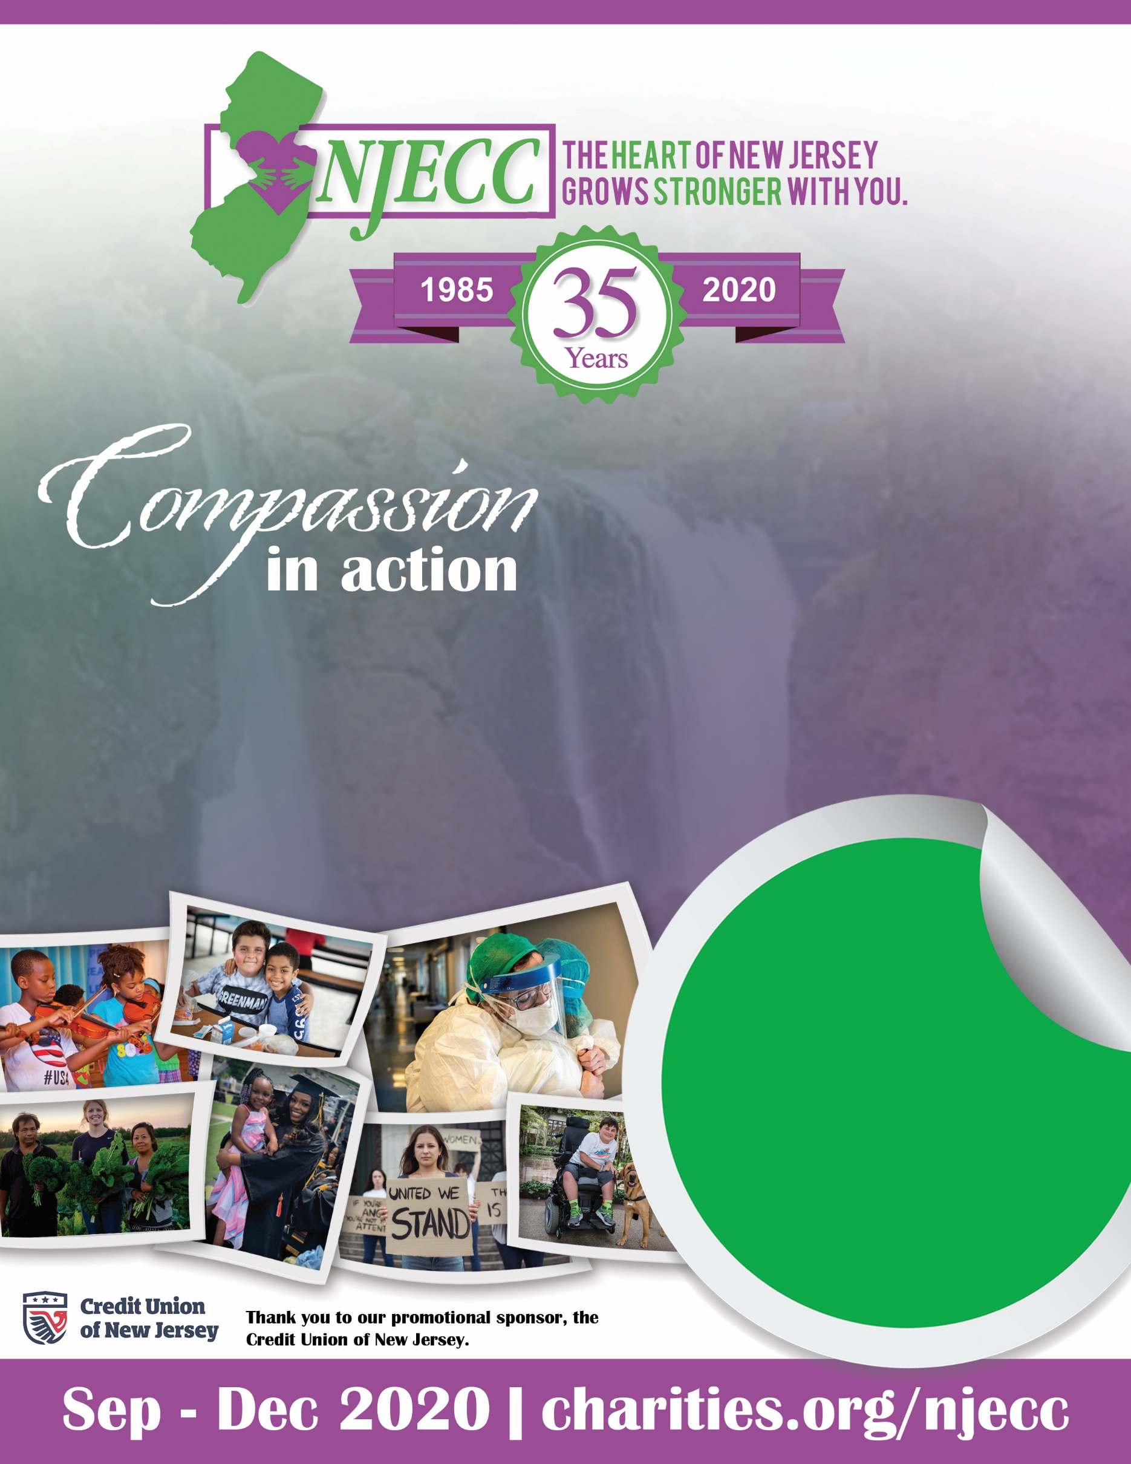

**Department of Health and Agriculture Kick Off**

**Oct**

**12th**

**9am – 2pm**

Grab a coffee and join us online to kick-off this year’s event virtually!

Sign up at the link below or email [coordinator email] for more details.

[insert link to sign up form here]